Design and Maintenance
General Overview

Introduction:-
The problem was abstracted away into six main categories of class: Game, Board, Tile, Dice, Card and Player. There are also 'manager' classes to take care of the objects for each class.
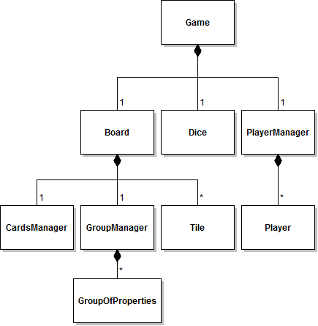

Class Breakdown:-
When the game is first started, an instance of the Game class is created. This object then creates instances of Board, Player and Card to 'populate' the game. Each Tile, Player and Card object describes one of many items, so vectors (arrays) containing collections of objects are kept in the Manager classes. So, for example, a vector (array) of Players is kept and managed in the PlayerManager class and a vector of Cards is stored and managed from the CardsManager class.

Player Manager

Introduction:-
At the start of the game, the system asks the user how many people are playing, and for their names. These actions are performed by the Game object and are then used by the Player Manager class to create Player instances.

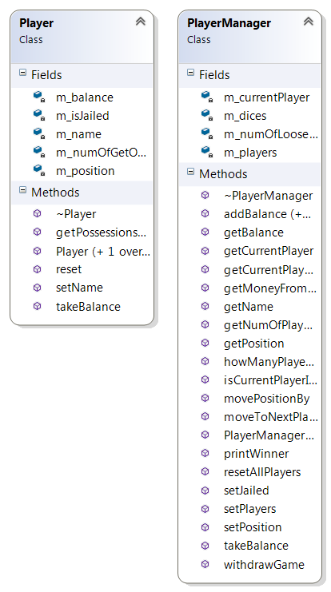
Class Breakdown:-

- The Game class is not really a proper object as such, more just a wrapper for the main game loop. When the program is first run, it simply sets up the game by creating PlayerManager and Board objects. A Dice object is also created.
- The PlayerManager object asks the user for the number or players and their names. This information is used to populate an array of Player objects.
- The Board object reads tile details in from a text file and populates an array of Tile objects. Each tile object contains information such as the group it belongs to (as handled by the GroupManager class) and the action performed when the player lands on it.
- Once the Player and Board objects have been initialised and put into arrays, the Game class calls a takeTurn method. This method is called each time a player takes a turn. It rolls the dice, moves the player and takes actions specified by the tile a player lands on.
- Every time a player takes a turn, the Player Manager class manipulates their player object, changing its properties and calling methods.

